**Multiplatform Input Analysis**

**Jason Captor/Cactus Games**

**General Strategy**

To simplify the requirements of porting to 3 separate platforms, I have chosen to keep the gameplay and input methods as simplistic as possible, using input methods common to all target platforms.

**Platform 1** – HP Reverb G2

**Controller** – Controller Name

Controller Diagram

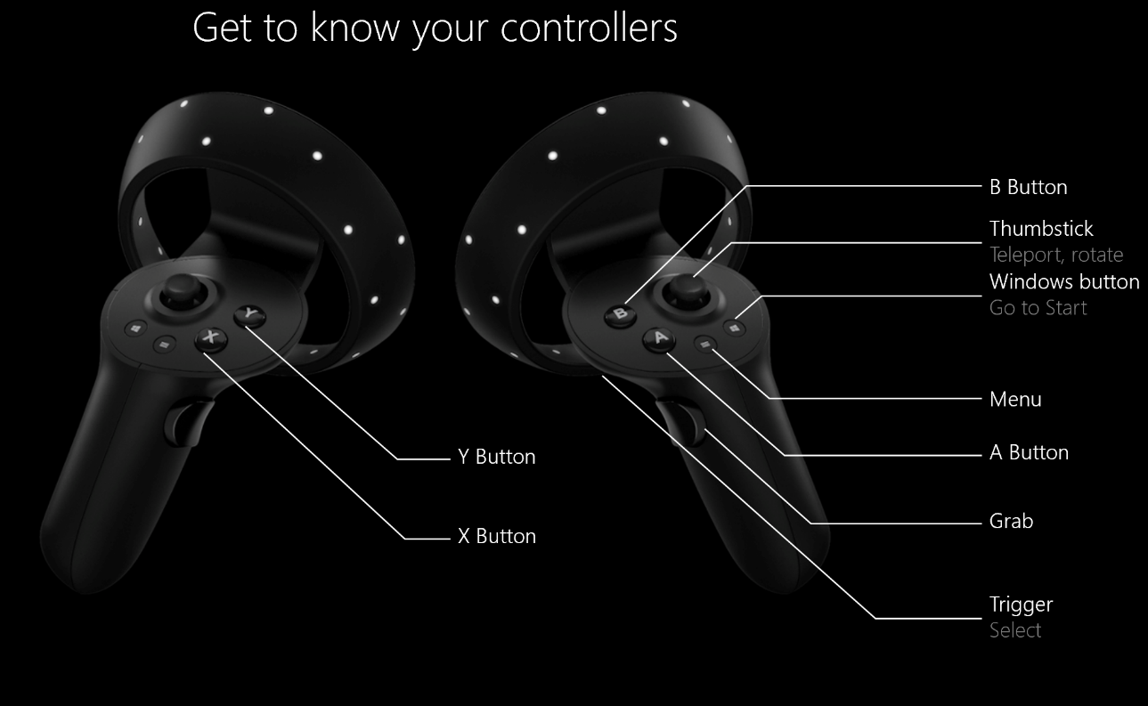

**Porting Considerations**

*[Please explain here what is unique about this controller compared to other models and what issues one may encounter when building a multiplatform game that uses these controllers. It is also appropriate to mention ways in which the controllers may be actually suited to multiplatform release.]*

**Platform 1** – Platform Name

**Controller** – Controller Name

Controller Diagram [Insert Image Here]

**Porting Considerations**

*[Please explain here what is unique about this controller compared to other models and what issues one may encounter when building a multiplatform game that uses these controllers. It is also appropriate to mention ways in which the controllers may be actually suited to multiplatform release.]*

**Platform 1** – Platform Name

**Controller** – Controller Name

Controller Diagram [Insert Image Here]

**Porting Considerations**

*[Please explain here what is unique about this controller compared to other models and what issues one may encounter when building a multiplatform game that uses these controllers. It is also appropriate to mention ways in which the controllers may be actually suited to multiplatform release.]*